Title (Times New Roman, bold, 14)

Author 1^{a,}* , Author 2^{b} (Authors are advised to update their ORCID; instructions are provided on the last page)
ª Affiliation1
^{b} Affiliation2

Abstract
The abstract should be between 150 and 200 words in length. It should cover the following elements: relevance/timeliness, objectives, research methodology, and key results or novel contributions (Times New Roman, italic, 11 pt).
Keywords: List 3–5 keywords from the article in Vietnamese, arranged in alphabetical order and separated by semicolons (;).

JEL classification: Find the appropriate code at Link.
Citation: (leave blank)

1. Introduction (Times New Roman, bold, 12)
The Introduction should present the background and nature of the research problem, as well as an overview of the existing body of knowledge in the field. This section must clearly state the purpose, scope, and general approach of the study, while also defining the research hypotheses and/or objectives. The paper must demonstrate the author's command of relevant research and include full, appropriate citations of sources in the field. Key works directly relevant to the study must not be omitted. (Times New Roman, 12, spacing 1.2)
The Introduction must clearly state the paper's objectives while outlining the research context. The Literature Review should focus exclusively on articles, books, and other sources directly relevant to the specific research questions addressed in the paper. The study's theoretical framework may be presented in a separate section that fully explains the rationale for the research, identifies gaps in the existing literature, and clarifies the practical value of the proposed theoretical foundation.

2. Literature review

2.1. Overview (Times New Roman, italic and bold, 12)
The literature review should focus on analyzing studies with subjects, methodologies, and findings directly relevant to the topic addressed in the article. The Journal of Management and Economics encourages authors to synthesize and cite scientific papers published in reputable international journals indexed in databases such as Scopus and Web of Science (SCI, SCIE, SSCI, etc.), as well as in specialized domestic journals recognized on the list published by the State Council for Professorship.

2.2. Theoretical Framework/Research Model (Times New Roman, italic and bold, 12)
This section presents the theoretical and practical basis of the study, including relevant theories, concepts, and factors, serving as the foundation for proposing the research model and hypotheses.

3. Research methodology
The research methodology section details the following:
- Research design.
- Data collection methods: Covering both secondary and primary data. For primary data, clearly outline the study population, methods for determining sample size and the study sample, sampling techniques, and data collection procedures.
- Data analysis methods: Describe the methods and models used to analyze the research data.

4. Discussion of research results
Data tables are presented in the format shown below. The table number (in bold) and the table title are placed above the table and centered. The data source is placed below and to the right of the table, in italics. Table notes (if any) are placed below the table, left-aligned. The table must be referred to within the body of the article.
Table 1. Indicator reflecting the academic performance of students at the University of Economics, Hue University.
Variable | N | … | Min
Entry scrore | 350 | … | 21
Learning motivation | 345 | … | 53
… | … | … | …
… | … | … | …
… | … | … | …
Note: N is the number of observations, Min is the minimum value
Source: Tran et al. (2010)
A comma (,) is used to separate larger place-value groups (such as thousands, millions, and billions).
A period (.) is used to separate the whole number part from the fractional part (placed after the ones digit).
Figures must have captions. Figure captions are formatted like table titles and placed below the image. All figures must be referred to in the body of the article.

Figure 1. Statistics on coffee production volume and production value.
Source: Compiled and illustrated by authors.
Equations within the body of the paper are presented using the Microsoft Word Equation function, italicized, centered, and numbered sequentially.
$\frac{-b±\sqrt{b^{2}-4ac}}{2a}$ (1)
Below is an example of how to present a bulleted or numbered list. Please cut this sample list and paste it into the appropriate place in the article:
- A
- B
When citing sources within the text, use the author's surname followed by the year of publication. If you wish to emphasize the author or if the author's name is part of the sentence structure, include the name in the sentence and place the year of publication in parentheses; for example: “Nguyen et al. (2003) argue that...” When simply citing a source for a statement or information without emphasizing the author, place both the author's name and the year of publication in parentheses at the end of the sentence or at an appropriate point within it; for example: “... has been noted in previous studies (Nguyen et al., 2003).”
For works with two or more authors, list only the surname of the first author followed by “et al.” If citing multiple works by the same author or group of authors published in the same year, append the letters a, b, c, etc., after the publication year to distinguish between them.

5. Conclusion
Summarize the key research findings, the paper's novel contributions, and the implications for policy and governance. Additionally, the author may address the study's limitations and propose directions for future research.

Acknowledgements
The authors would like…

Declaration of conflict of interest
The authors declare that they have no known competing financial interests or personal relationships that could have appeared to influence the work reported in this paper.

References
Use APA format for references.
Guidance at: https://www.mendeley.com/guides/apa-citation-guide/
Authors are encouraged to use reference management software such as Mendeley or Zotero.

APPENDIX
F-test results
H₀: In the absence of individual effects, Pooled OLS is appropriate.
H₁: With individual effects, Pooled OLS is inappropriate.
Model | F-stat | Prob | Result
Pooled OLS and FEM | 37.96 | 0.0000 | The FEM model is more suitable than Pooled OLS.
Source: Authors’ analysis using Stata.

INSTRUCTIONS FOR UPDATING ORCID INTO AUTHOR INFORMATION

Step 1: Right-click the ORCID logo.


Step 2: Select Edit Link.


Step 3: Update the author's 16-digit ORCID and click OK.
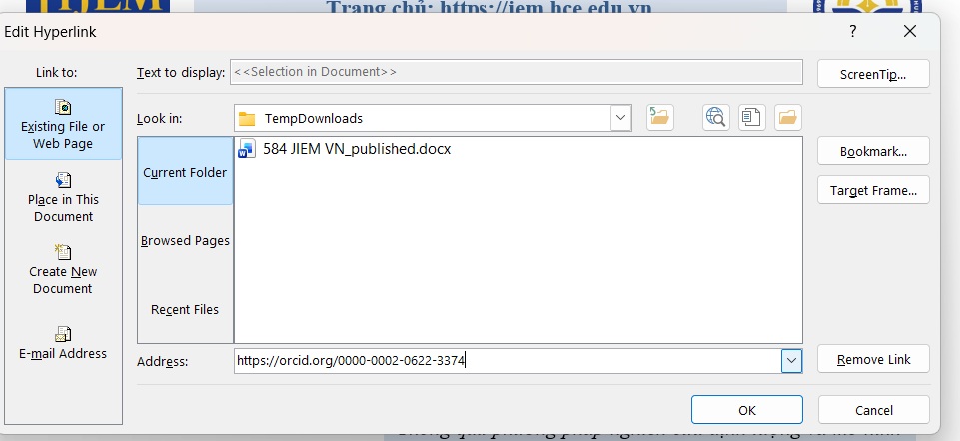

Do the same for each author.

